**Creating users**

* Window Key + R: Lusrmgr.msc

**Creating groups**

* Window Key + R: Lusrmgr.msc

**Power user**

* Window Key + R: Lusrmgr.msc
  + Click Users Folder
  + Right Click: the users account
  + Select Properties
  + Member of > Add: Power Users

**Creating a Domain ACCOUNT/USER**(instructions below ARE done on the **SERVER**)

* Start > Administrative Tools > Active Directory Users and Computers
* Click on the “domain.com” > Right click Users > New > User

**Joining a COMPUTER/WORKSTATION to a DOMAIN**:

(instructions below are done on the **CLIENT**)

* Control Panel > System & Security > System
* Advanced System Settings
* Computer name [Tab] > Change > Member of: Domain
  + **if cant connect:** Check NIC for Preferred DNS
* Supply Administrator username and password

**WET (Windows easy Transfer): Saving Profile**

___ Log out and log back in as the Administrator. You must be the administrator to be able to run the WET program.

___ Click on the **Start** button and then type **Windows Easy Transfer**.

___ On the first screen click **Next**.

___ On the next screen, select **An external hard drive or USB flash drive**.

___ On the next screen, choose **This is the old computer**.

___ On the next screen, clear the check box opposite Administrator. We do not want to transfer the Administrator account. Click on **Next**.

___ On the next screen, do not bother supplying a password.

___ Save the file in the **SavedSettings** folder that you created earlier. Rename the file to **<lastname>.**MIG where lastname is your lastname.

**Wireshark**

Removing frame color: View > Colorize Packet List

**Make the user a standard user (POWER USERS)**

We want this account to be a **standard** account so we have to add the user to

the **power user** group.

Right-click on Carl’s account and select **Properties**. Click on the **Member Of** tab. Add the **power users** group. (via lusrmgr.msc)

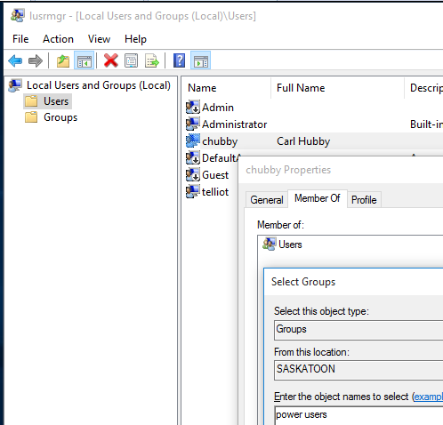

**ARP Cache (MAC table)**

(ARP is used to map the IP Address of a computer to its MAC address)

**Display** ARP cache (MAC Table) in terminal: arp –a

**Delete** all hosts in ARP cache: arp –d *

**DNS Cache**

(DNS is used to map the IP Address of a computer to its domain name ie: blacktone.com)

**Clear** DNS cache: ipconfig /flushdns

**Display** DNS cache: ipconfig /displaydns

**Creating a DOMAIN Controller / Active Directory (DNS Server)**

* Start > Type: dcpromo
  + Create a new domain…
  + Type a new domain (ie: blacktone.com)
  + Choose Server 2008 R2
  + Accept the defaults for NTDS
  + Restart VM

**NetBIOS Cache**(NetBIOS is used to translate a computers hostname into its IP address ie: Ottawa)

**Clear** netbios cache: nbtstat –R

**Display** netbios cache: nbtstat –c

Changing **NetBIOS name:**

* Control Pannel > System & Security > System
* Advanced System Settings > [TAB] Computer Name > Change

**Negative Entry Cache**

* See notes on LMHOST files (for NetBIOS negative cache)
* For DNS negative cache entry:
  + Ping a domain on the DNS that doesn’t exist:
    - Kargarie.blacktone.com
  + Display the negative cache:
    - Ipconfig /displaydns

**Adding WINS Server (ie: Calgary)**

* Start > Administrator Tools > Server Manager
* Features > Add Features
* Configure Calgary’s NIC so WINS points to itself (10.1.1.10)
* Right click CALGARY > Refresh
* **Display Active Records:** 
  + Expand CALGARY > Right click Active Registration > Display Records > Find Now

**Configuring WINS Clients**

* IPv4 Properties > Advanced > WINS [TAB]
* Force Register NetBIOS records with WINS:
  + nbtstat –RR

**LMHOST files**

(used to statically map the IP address to NetBIOS names)

**W7/W10:** C:\windows\system32\drivers\etc

* Clear the netbios cache on Ottawa or Hamilton before pigning
  + Nbtstat –R
* Add a #PRE ( 20.20.20.20 Glenn #PRE) for **negative cache entry**

**HOST files**

(used to statically configure the IP address to DNS mappings)

**W7/W10:** C:\windows\system32\drivers\etc

* Add the IP then Name.com to the host file
  + Ipconfig /displaydns to display the cache entry

**Adding a LOCAL Printer**

* Start > Devices & Printers > Add a printer
* Add a local printer > LPT1 > Install printer driver > etc…

**Adding a NETWORKED Printer**

* Control Panel > View Devices and printers
* Add printer > “Add a Network… printer” > Add a Printer using TCP/IP
* **Select**: TCP/IP Device [Dropdown menu]
  + **Hostname or IP Address:** 10.1.1.55 (your network printer ip)
  + **Port Name:** 10.1.1.55 (your network printer ip)
  + Clear “Query Printer” if printer doesn’t exist [Click NEXT when done]
  + Select: Generic Network Card
  + Install printer driver
  + Done

**Printing to a shared LOCAL Printer**

* Control Panel > View Devices and printers
* Add printer > “Printer that I want isn’t listed
* Shared printer by name >
  + \\domain-name\printer-name
  + \\ottawa\lopez
* **SPOOLING**: c:\windows\system32\spool\printer
  + .SHD & .SPL
* **DACL Control**
  + Open “Printer Properties” of the printer you want to DACL control
  + Security [TAB] > Remove “Everyone”

**Printer Pooling**

* Control Panel > View Devices and printers
* Add another NETWORKED printer (net printer 2)
* Open “Printer Properties” of the first network printer (net printer)
  + Check: “Enable Printer Pooling”
  + Check: The second printer you added